Entrance  1.  Be Thou my Vision, O Lord of my heart;  be all else but naught to me, save that Thou art;  be Thou my best thought in the day and the night,  both waking and sleeping, Thy presence my light.  2. Be Thou my Wisdom, and Thou my true Word;  be Thou ever with me, and I with Thee, Lord;  be Thou my great Father, and I Thy true son;  be Thou in me dwelling, and I with Thee one.  3. Riches I heed not, nor man's empty praise;  be Thou mine inheritance, now and always;  be Thou and Thou only the first in my heart,  O high King of heaven, my Treasure Thou art.  Psalm | Offertory  Ag Críost an Síol  Ag Críost an fomhar  I n-iothalainn Dé  go dtugtar sinn  Ag Críost an mhuir  Ag Crost an t-iasc  i líontaibh Dé  go gcastar sinn | O fhás go haois  is o aois go bás  do dhá láimh a Criost  anall tharainn  O bhás go críoch  ni críoch ach ath-fhás  I bParthas na nGrást  go rabhaimid
1 The Lord’s my Shepherd, I’ll not want;  He makes me down to lie  In pastures green; He leadeth me  The quiet waters by.  2 My soul He doth restore again,  And me to walk doth make  Within the paths of righteousness,  E'en for His own name’s sake.  3 Yea, though I walk in death’s dark vale,  Yet will I fear no ill;  For Thou art with me, and Thy rod  And staff me comfort still.  4 Goodness and mercy all my life  Shall surely follow me,  And in God’s house forevermore  My dwelling-place shall be.  Communion | Soul of my saviour  Sanctify my breast.  Body of Christ,  Be thou my saving guest.  Blood of my saviour,  Bathe me in thy tide.  Wash me with waters,  Flowing from his side.  Strength and protection  May thy passion be.  Oh blessed Jesus  Hear and answer me.  Deep in thy wounds Lord,  Hide and shelter me  So shall I never,  Never part from thee. | Guard and defend me  From the foe malign.  In death’s dread moments  Make me only thine.  Call me and bid me  Come to thee on high.  Where I may praise thee  With thy saints for aye
Recessional  - Lead, kindly Light, amid th'encircling gloom,  Lead Thou me on;  The night is dark, and I am far from home,  Lead Thou me on;  Keep Thou my feet; I do not ask to see  The distant scene;...one step enough for me.  - I was not ever thus, nor prayed that Thou  Should lead me on;  I loved to choose and see my path, but now  Lead Thou me on;  I loved the garish day, and spite of fears,  Pride ruled my will; remember not past years.  - So long Thy pow’r has blest me, sure it still  Wilt lead me on,  O’er moor and fen, o’er crag and torrent, till  The night is gone,  And with the morn those angel faces smile,  Which I have loved .... long since, and lost awhile. | Mungret Union Mass  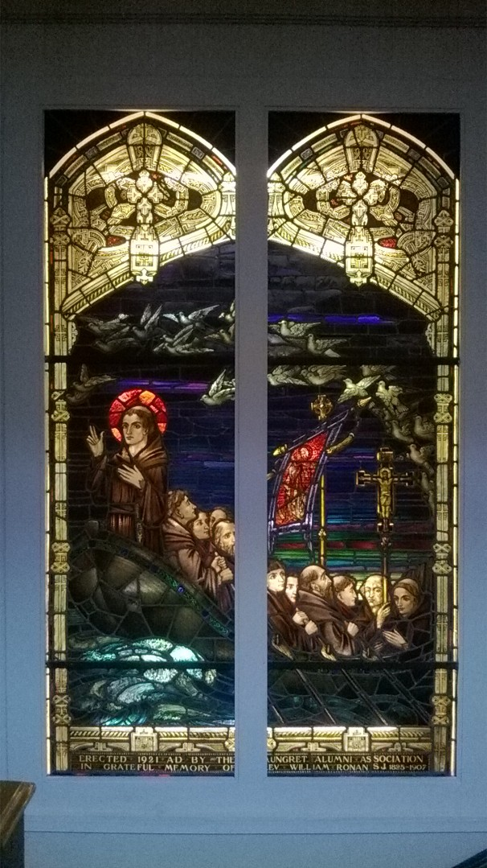  Church of the Assumption,  Booterstown, Co. Dublin  02 December 2017  Chief Celebrant : Fr Joe Brennan SJ  Concelebrants : Fr John Guiney SJ & Fr William King
- Members in attendance will be invited by Fr Joe Brennan to pray for particular intentions in the prayers of the faithful, you may wish to give this some thought.
- There may be someone recently deceased who you wish to be remembered in our prayers
- You are also asked to sing the hymns heartily from the congregation, there may be an opportunity to practise for those who arrive early, the mass will start at 11:30.

